**Data set : SASHELP.USECON**

title1 "Sales of Passenger Cars";

symbol1 i=spline v=dot;

axis2 label=(a=-90 r=90 "Vehicles and Parts" )

order=(6000 to 24000 by 3000);

title1 "Sales of Passenger Cars";

proc sgplot data=sashelp.usecon;

series x=date y=vehicles / markers;

xaxis values=('1jan80'd to '1jan92'd by year);

yaxis values=(6000 to 24000 by 3000);

format date year4.;

run;

**Output 16.1.1: Monthly Passenger Car Sales**

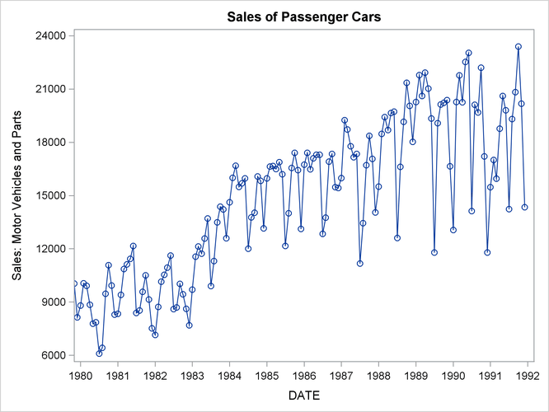

The following statements produce the forecast:

proc forecast data=sashelp.usecon interval=month

method=winters seasons=month lead=12

out=out outfull outresid outest=est;

id date;

var vehicles;

where date >= '1jan80'd;

run;

The INTERVAL=MONTH option indicates that the data are monthly, and the ID DATE statement gives the dating variable. The METHOD=WINTERS specifies the Winters smoothing method. The LEAD=12 option forecasts 12 months ahead. The OUT=OUT option specifies the output data set, while the OUTFULL and OUTRESID options include in the OUT= data set the predicted and residual values for the historical period and the confidence limits for the forecast period. The OUTEST= option stores various statistics in an output data set. The WHERE statement is used to include only data from 1980 on.

The following statements print the OUT= data set (first 20 observations):

title2 'The OUT= Data Set';

proc print data=out (obs=20) noobs;

run;

The listing of the output data set produced by PROC PRINT is shown in part in Output 16.1.2.

**Output 16.1.2: The OUT= Data Set Produced by PROC FORECAST (First 20 Observations)**

|  |
| --- |
| Sales of Passenger Cars |
| The OUT= Data Set |

| **DATE** | **_TYPE_** | **_LEAD_** | **VEHICLES** |
| --- | --- | --- | --- |
| JAN80 | ACTUAL | 0 | 8808.00 |
| JAN80 | FORECAST | 0 | 8046.52 |
| JAN80 | RESIDUAL | 0 | 761.48 |
| FEB80 | ACTUAL | 0 | 10054.00 |
| FEB80 | FORECAST | 0 | 9284.31 |
| FEB80 | RESIDUAL | 0 | 769.69 |
| MAR80 | ACTUAL | 0 | 9921.00 |
| MAR80 | FORECAST | 0 | 10077.33 |
| MAR80 | RESIDUAL | 0 | -156.33 |
| APR80 | ACTUAL | 0 | 8850.00 |
| APR80 | FORECAST | 0 | 9737.21 |
| APR80 | RESIDUAL | 0 | -887.21 |
| MAY80 | ACTUAL | 0 | 7780.00 |
| MAY80 | FORECAST | 0 | 9335.24 |
| MAY80 | RESIDUAL | 0 | -1555.24 |
| JUN80 | ACTUAL | 0 | 7856.00 |
| JUN80 | FORECAST | 0 | 9597.50 |
| JUN80 | RESIDUAL | 0 | -1741.50 |
| JUL80 | ACTUAL | 0 | 6102.00 |
| JUL80 | FORECAST | 0 | 6833.16 |

The following statements print the OUTEST= data set:

title2 'The OUTEST= Data Set: WINTERS Method';

proc print data=est;

run;

The PROC PRINT listing of the OUTEST= data set is shown in Output 16.1.3.

**Output 16.1.3: The OUTEST= Data Set Produced by PROC FORECAST**

|  |
| --- |
| Sales of Passenger Cars |
| The OUTEST= Data Set: WINTERS Method |

| **Obs** | **_TYPE_** | **DATE** | **VEHICLES** |
| --- | --- | --- | --- |
| **1** | N | DEC91 | 144 |
| **2** | NRESID | DEC91 | 144 |
| **3** | DF | DEC91 | 130 |
| **4** | WEIGHT1 | DEC91 | 0.1055728 |
| **5** | WEIGHT2 | DEC91 | 0.1055728 |
| **6** | WEIGHT3 | DEC91 | 0.25 |
| **7** | SIGMA | DEC91 | 1741.481 |
| **8** | CONSTANT | DEC91 | 18577.368 |
| **9** | LINEAR | DEC91 | 4.804732 |
| **10** | S_JAN | DEC91 | 0.8909173 |
| **11** | S_FEB | DEC91 | 1.0500278 |
| **12** | S_MAR | DEC91 | 1.0546539 |
| **13** | S_APR | DEC91 | 1.074955 |
| **14** | S_MAY | DEC91 | 1.1166121 |
| **15** | S_JUN | DEC91 | 1.1012972 |
| **16** | S_JUL | DEC91 | 0.7418297 |
| **17** | S_AUG | DEC91 | 0.9633888 |
| **18** | S_SEP | DEC91 | 1.051159 |
| **19** | S_OCT | DEC91 | 1.1399126 |
| **20** | S_NOV | DEC91 | 1.0132126 |
| **21** | S_DEC | DEC91 | 0.802034 |
| **22** | SST | DEC91 | 2.63312E9 |
| **23** | SSE | DEC91 | 394258270 |
| **24** | MSE | DEC91 | 3032755.9 |
| **25** | RMSE | DEC91 | 1741.481 |
| **26** | MAPE | DEC91 | 9.4800217 |
| **27** | MPE | DEC91 | -1.049956 |
| **28** | MAE | DEC91 | 1306.8534 |
| **29** | ME | DEC91 | -42.95376 |
| **30** | RSQUARE | DEC91 | 0.8502696 |

The following statements plot the residuals. The plot is shown in Output 16.1.4.

title1 "Sales of Passenger Cars";

title2 'Plot of Residuals';

proc sgplot data=out;

where _type_ = 'RESIDUAL';

needle x=date y=vehicles / markers markerattrs=(symbol=circlefilled);

xaxis values=('1jan80'd to '1jan92'd by year);

format date year4.;

run;

**Output 16.1.4: Residuals from Winters Method**

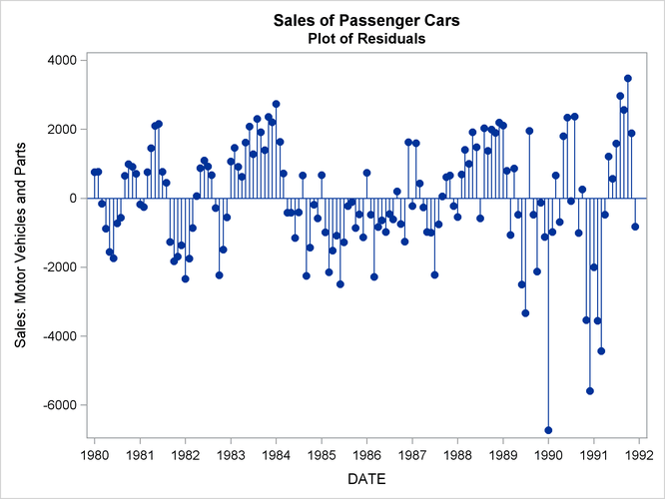

The following statements plot the forecast and confidence limits. The last two years of historical data are included in the plot to provide context for the forecast plot. A reference line is drawn at the start of the forecast period.

title1 "Sales of Passenger Cars";

title2 'Plot of Forecast from WINTERS Method';

proc sgplot data=out;

series x=date y=vehicles / group=_type_ lineattrs=(pattern=1);

where _type_ ^= 'RESIDUAL';

refline '15dec91'd / axis=x;

yaxis values=(9000 to 25000 by 1000);

xaxis values=('1jan90'd to '1jan93'd by qtr);

run;

The plot is shown in Output 16.1.5.

**Output 16.1.5: Forecast of Passenger Car Sales**

